**Kreeger Theater**

**Sarah Silverman’s *The Bedwetter***

**Information for Ushers**

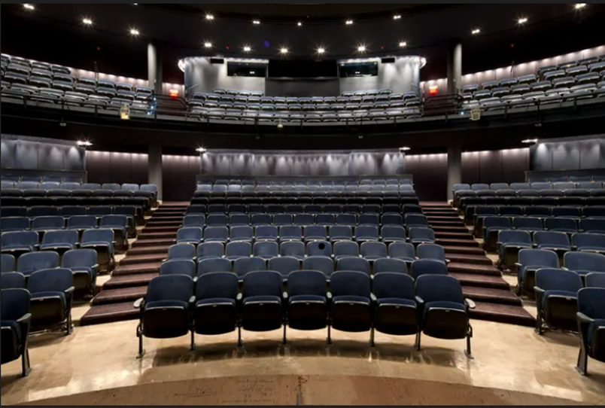

**SPECIFIC INFORMATION FOR:** **Sarah Silverman’s *Bedwetter***

**Show Length**: The show is approximately 1 hour and 45 minutes with no intermission.

**Content**: This production will contain *haze, strobe lights, adult language, and themes relating to suicide.*

**Pre-show and Usher check-in:** Usher check-in will begin 90 minutes prior to the start of the show.

* If you are an **aisle usher**, please go directly to your theater once you have checked in.
  + The usher speech will begin **1 hour prior to the start of the show**. Please be sure you are in the theater for the usher speech as this will provide important information for the performance.
* If you get assigned as a **ticker scanner**, please proceed directly to the Visitors Services Desk for show-specific information.
  + Ticket scanners will act as Arena Stage ambassadors by welcoming all patrons to the building and answering any questions our patrons may have **IN ADDITION TO SCANNING TICKETS**. Ticket scanners **MUST stay for the entirety of the show** and act as Arena Stage ambassadors post show by thanking all patrons for coming and answering any questions our patrons may have.

**House open and Patron load-in:** The house will open approximately 30 minutes prior to the performance. Please be sure that you are in place and ready to go **35 minutes prior** to the start of the performance. Do not open any doors or welcome any Patrons into the theater until the House Manager announces that the house is open.

* While Patrons are entering the theater, please welcome them with a kind and upbeat greeting! Remember you are permitted to walk patrons to their seats and/or direct them to their seat, your choice!
  + If you walk a Patron to their seat, please hand them a program once they are settled.
  + If you direct a Patron to their seat, hand them a program after you direct them and ask them to watch their step as they make their way to their seat.
* The House Manager will check in with you regularly throughout the Patron load-in.
  + When the House Manager checks in with you, please feel free to pass along any patron questions or concerns during this time! This is a great time to inquire about any patron re-seating requests.
* If the House Manager is not in your section and you require assistance, **please do not abandon your position**, instead, please pass the message along from Usher to Usher, and it will make its way to a House Manager.
* The House Manager will do a final check-in a few minutes before the show starts.
  + You may still ask about any Patron re-seating questions at this time, but please do not hold them all for this time as this can negatively impact the show’s start time.
* If you are an Aisle usher, please walk the no cell phones sign up and down the aisles while giving **ALL** Patrons a gentle reminder to silence any electronic devices including phones and smart watches.
* If you are a ticket scanner, please hand all unscanned ticket stubs to the House Manager and let them know of any major scanner issues.
* All Ushers should stand at the back of the theater and await the late seating break(s).

**Late Seating Break**: The "late seating break" is a time in each performance, designated by the Director and Senior Artistic Staff as to when latecomers may be seated within the theater. The time is carefully and meticulously selected so it will be the **least disturbing**, as well as **SAFEST** to/for the audience and the actors. **Please ONLY seat patrons during the late seating breaks and NOT when the House Managers hand them off to you.** ***DO NOT ASK HOUSE MANAGERS WHEN THE LATE SEATING BREAK IS WHILE THE PERFORMANCE IS IN PROGRESS. IF YOU NEED A REMINDER, PLEASE ASK DURING PATRON LOAD-IN.***

* The only late seating break is 7 minutes into the show
  + After “Crazy Donny’s” song; Beth Ann and the Jingle Singers exit. Scene change from Bedroom to Donald’s house.
* Once the late seating break has passed, you all may take your seats. **Please do NOT take seats in the first 4 rows of the theater.**
* Depending on how sold a show is, there may not be seats for Ushers. Ushers are welcome to stand against the back wall of the Kreeger if there are no seats available.
* If you do get a seat, please keep in mind that you may be asked to move if a Patron shows up after the seating break.

**During the show**: Remember, **you are on duty for the entirety of the show**. You are our eyes and ears in the house.

* **Please get up and alert a House Manager immediately** if you hear any cell phone or watch alarms, alerts, notifications, or any other disruptive sounds or behavior. It is much less distracting to get up in the middle of the show and alert us to this than it is to let it go on and tell us after the show. There will always be a House Manager at the Visitors Services Desk.

**After the show**: Once the show has concluded, **return to your assignments!**

* Aisle Ushers should go back to the top of their aisles.
  + Please remind Patrons to look out for any steps and help Patrons to find the restrooms and elevators.
  + Aisle Ushers **MUST** stay inside the theater until it is clear so that no Patrons get stuck inside or without the elevator.
* Ticket scanners **MUST** return to the lobby.
  + Once in the lobby, ticket scanners should thank Patrons for coming, ask how their visit was, and answer any questions our Patrons may have including directions to the lobby, elevators, garage, restrooms, and/or metro station.

**Usher Check-out**: Once the lobby and theater spaces have cleared of most patrons, ushers may check-out. Lanyards should be returned to a staff member at the Visitors Services Desk.

**GENERAL INFORMATION FOR THE Kreeger**:

* The orchestra has row’s A-J and the mezzanine has rows AA-EE
* Accessible seats are J1,3,5; and J 2,4,6 in the orchestra and DD 1,3,5; and DD 2,4,6 in the mezzanine
* If you face the stage, the even numbered seats are on your right- hand side, the odd numbered seats are on your left-hand side and the three-digit seats are in the middle section.

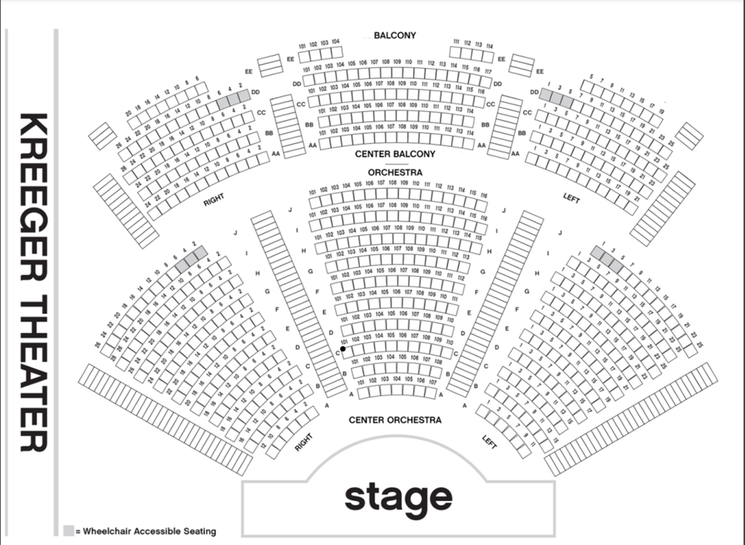

**House Rules**:

* Please remind patrons that all food should be finished in the lobby before they enter the theater.
* Cups with a lid are permitted inside the theater. Rworld cups should be placed in the yellow bins at the end of their use.
* Children under the age of 5 are not permitted in the theater for this production. Please alert the House Manager if you see a child that appears to be under age 5.
* All phones, alarms, alerts, and smart watches should be silenced before the start of the performance.
* Masks are no longer required except for Mask Required Performances on Saturday, February 8th at 2:00pm and Tuesday, March 11th at 7:30pm.
  + Ushers who wish to opt in or opt out of mask required performances should contact House Management at usher@arenastage.org to switch their usher date.

**Patrons with Walkers/Canes/Wheelchairs**: If you take a patron's walker, cane, wheelchair or any other mobility device at the beginning of the show to stow it for them, then you are then responsible for returning it to the patron at intermission and after the performance has concluded. You will be that patron's personal concierge for the evening.